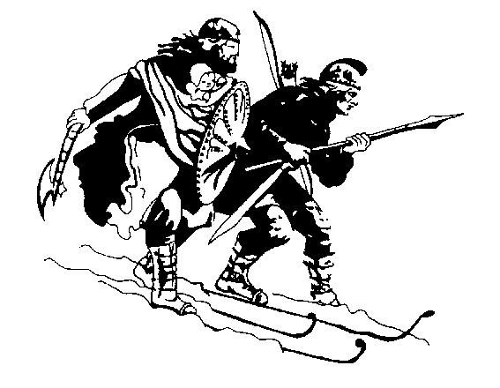
Birkebeiner Nordic Ski Club Inc.
PO Box 192, Mount Beauty 3699
Mobile: 0409 332 642

Secretary’s email: secretary@birkebeiner.org.au
Website: www.birkebeiner.org.au

National Team Member Grant Application
Please complete this form by typing into it and email it to the secretary as an attachment <secretary@birkebeiner.org.au> or post to the address above. Applications close on 28th October 2024.
Name
Postal address
Postcode
Phone Mobile
Date of birth I have been a BNSC member for years.
Your Team/Squad
Email (Please print clearly!)
Do you agree to provide a one page trip report for the Bulletin on your return?
Date: …………………………………
Please include a one to two-page application that includes the following:
1. Your trip details and goals
2. Whether you are participating in a team trip, a SSA recognised program, or going it alone (or a combination)
3. Outline the major competitions you will be entering
4. Personal budget, including any other grants or funding you expect to receive (Please attach it on a separate page if necessary).
5. Please outline how you have contributed to Birkebeiner Nordic Ski Club in the past season and how you plan to contribute in the future (e.g. junior events/camps, races, committees, policy updating, grant writing, working bees, guest speaking).
6. What other funding or sponsorship will you receive?

Note: Applications close on 28th October 2024. All applications will be acknowledged by email. If you don’t receive an acknowledgement, please ring Secretary — Michell Forrer mob: ‭0417 206 672‬ to confirm that your application was received. The club takes no responsibility for undelivered applications, and late applications will not be accepted.

